DBMS CAPSTONE PROJECT REPORT
HOSPITAL MANAGEMENT SYSTEM
A DBMS Capstone Project Report submitted in partial fulfillment of the requirements for the award of the degree of
BACHELOR OF TECHNOLOGY
in
ARTIFICIAL INTELLIGENCE AND MACHINE LEARNING
Submitted By
P. UMASRINU – 25B11AI891
P. UDAYAKIRAN – 25B11AI880
P. MADHAVAN – 25B11AI873
P. SUDEEP – 25B11AI941
Under the esteemed guidance of
Mrs. G. L. Narasamba Vanguri,M.Tech.,(Ph.D)
Project Guide
Mr. P. V. V. S. D. Nagendrudu, M.Tech.,(Ph.D)
Project Co-Guide

DEPARTMENT OF ARTIFICIAL INTELLIGENCE AND MACHINE LEARNING

Aditya Nagar, ADB Road, Surampalem, Andhra Pradesh, India
2026 – 2027

CERTIFICATE
This is to certify that the DBMS Capstone Project report entitled “Hospital Management System” is being submitted by P. Umasrinu (Roll No. 25B11AI891), P. Udayakiran (Roll No. 25B11AI880), P. Madhavan (Roll No. 25B11AI873) and P. Sudeep (Roll No. 25B11AI941) in partial fulfillment of the requirements for the award of the B.Tech. degree in Artificial Intelligence and Machine Learning.
Project Guide  Mrs. G. L. Narasamba, M.Tech.,(Ph.D)  Assistant Professor | Head of the Department  Dr. K. Naga Bhargavi M.Tech, Ph.D.  Associate Professor & HOD
Project Co-Guide
Mr. P. V. V. S. D. Nagendrudu, M.Tech.,(Ph.D)
Assistant Professor
The work documented in this report was carried out as part of the Database Management Systems Cornerstone Project during the academic year 2026–2027, and records the database design, implementation, testing and documentation undertaken by the team.

External Examiner

DECLARATION
We hereby declare that the DBMS Capstone Project entitled “Hospital Management System” is a genuine work carried out by us. The database design, SQL implementation, queries and documentation presented in this report are our own work, completed under the guidance of Mrs. G. L. Narasamba and co-guidance of Mr. P. V. V. S. D. Nagendrudu, Department of Artificial Intelligence and Machine Learning, Aditya University, Surampalem.
We further declare that this work has not been submitted, in full or in part, for the award of any degree of this or any other educational institution.
Project Associates
P. Umasrinu (25B11AI891)
P. Udayakiran (25B11AI880)
P. Madhavan (25B11AI873)
P. Sudeep (25B11AI941)

Date: 01 October 2026
Place: Surampalem
ACKNOWLEDGEMENT
It is with immense pleasure that we express our indebted gratitude to our project guide Mrs. G. L. Narasamba and co-guide Mr. P. V. V. S. D. Nagendrudu, Department of Artificial Intelligence and Machine Learning, who guided us throughout the capstone project. We are thankful for the constant encouragement and valuable suggestions received at every review stage.
We are grateful to Dr. K. Naga Bhargavi, Head of the Department, for inspiring us and for arranging the facilities and resources needed for this project.
We extend our sincere thanks to the Management, Dr. M. Sreenivasa Reddy, Deputy Pro-Chancellor, Dr. M. B. Srinivas, Vice-Chancellor, and Dr. A. Ramesh, Pro Vice-Chancellor (Engineering & Sciences), for providing an excellent academic environment.
Not to forget, we thank the Teaching and Non-Teaching Staff, our parents and our friends, who have directly or indirectly supported us in completing this project on time.
Project Associates
P. Umasrinu (25B11AI891)
P. Udayakiran (25B11AI880)
P. Madhavan (25B11AI873)
P. Sudeep (25B11AI941)

PROJECT DOCUMENTATION REPORT
Hospital Management System
S.No | Student Name | Roll Number
1 | P. UMASRINU | 25B11AI891
2 | P. UDAYAKIRAN | 25B11AI880
3 | P. MADHAVAN | 25B11AI873
4 | P. SUDEEP | 25B11AI941

Guide: Mrs. G. L. Narasamba Vanguri,M.Tech.,(Ph.D)

Co-Guide: Mr. P. V. V. S. D. Nagendrudu, M.Tech.,(Ph.D)

Academic Year: 2026 – 2027
TABLE OF CONTENTS
Certificate i
Declaration ii
Acknowledgement iii
Project Documentation Report iv
1 ABSTRACT v
List of Figures vii
List of Tables vii
2 INTRODUCTION 1
2.1 Background 1
2.2 Purpose of the Database 1
2.3 Scope of the Project 1
3 PROBLEM STATEMENT 1
4 OBJECTIVES 2
5 TOOLS & TECHNOLOGIES USED 2
6 DATABASE DESIGN 3
6.1 Identified Entities 3
6.2 Entity Attributes 3
6.3 ER Diagram 5
6.4 Relationships & Cardinality 6
6.5 Relational Database Schema 7
6.6 Primary & Foreign Keys 9
6.7 Normalization 10
7 DATABASE IMPLEMENTATION 10
7.1 DDL – Database and Table Creation 10
7.2 Sample Data – DML 12
7.3 Constraints & Data Integrity 13
7.4 DDL, DML & DQL Operations 13
7.5 CRUD Operations & SQL Queries 14
7.6 Data Integrity & Validation 16
7.7 Sample Outputs / Screenshots 17
8 MODULES & FUNCTIONALITIES 20
9 GITHUB REPOSITORY & TEAM RESPONSIBILITIES 20
10 DEMONSTRATION OF THE DATABASE 21
11 ENHANCEMENTS & FUTURE IMPROVEMENTS 21
12 CONCLUSION 22
13 REFERENCES 22
APPENDIX 23
A. Complete SQL Script Files 23
B. Additional Screenshots / Outputs 23

1. ABSTRACT
The Hospital Management System (HMS) is a relational database project designed to manage the day-to-day information of a hospital — patient registration, doctor and nurse records, departments, rooms, appointments, medical records, medicine stock and billing. Manual registers make records slow to search, easy to duplicate and hard to bill accurately. To overcome this, a normalised MySQL database named HospitalDB was designed from an Entity–Relationship model and implemented with nine related tables: Patient, Doctor, Department, Nurse, Room, Appointment, Medical_Record, Medicine and Billing.
The tables are connected through primary and foreign keys and protected by NOT NULL, UNIQUE, CHECK and DEFAULT constraints, so that every fact is stored once and linked correctly. The database was populated with 145 representative sample records and tested with DDL, DML and DQL statements, CRUD operations, joins, aggregate functions, GROUP BY / HAVING, subqueries, a view and indexes. Integrity checks confirmed that there are no duplicate patient IDs, no orphan appointments, all required patient fields are filled, and no expired medicine is in stock.
A web-based demo application with eight screens — Dashboard, Patients, Doctors, Appointments, Medical Records, Medicines, Billing and Reports — shows the database working end to end. In the demo, the billing screen reports 20 bills with a revenue of ₹1,84,500, an average bill of ₹9,225 and a highest bill of ₹32,000, all produced by SQL aggregate queries.
Keywords: Hospital Management, DBMS, MySQL, ER Diagram, Normalization, Primary Key, Foreign Key, SQL, Data Integrity.

LIST OF FIGURES
Figure 6.1 ER Diagram of the Hospital Management System 5
Figure 6.2 Primary and Foreign Key Links of the Appointment Table 9
Figure 7.1 Medical Records screen (Medical_Record + Patient + Doctor) 18
Figure 7.2 Medicine & Pharmacy screen (Medicine table) 18
Figure 7.3 Billing Management screen (Billing + Patient, aggregate functions) 19
Figure 7.4 Reports & DBMS Features screen (JOIN output and integrity validation) 19
LIST OF TABLES
Table 5.1 Tools and Technologies Used 2
Table 6.1 Identified Entities 3
Table 6.2 Entity Attributes 3
Table 6.3 Relationships and Cardinality 6
Table 6.4 Relational Schema of the Nine Relations 7
Table 6.5 Detailed Schema with Data Types and Constraints 7
Table 6.6 Foreign Keys and the Parent Tables They Reference 9
Table 6.7 Normalisation Steps Applied 10
Table 7.1 Number of Sample Records per Table 12
Table 7.2 Constraints Applied in HospitalDB 13
Table 7.3 SQL Operations and Queries 14
Table 7.4 Output of the Three-Table JOIN (Q7) 16
Table 7.5 Output of the Aggregate Query (Q9) 16
Table 7.6 Types of Data Integrity 16
Table 7.7 Validation Results 17
Table 8.1 Modules and Functionalities 20
Table 9.1 Repository Structure 20
Table 9.2 Team Responsibilities 21
Table 10.1 Demonstration Steps 21
Table A.1 SQL Script Files 23
Table B.1 Screenshot to Database Mapping

2. INTRODUCTION

2.1 Background
A hospital continuously handles large amounts of structured information: who the patients are, which doctor treats them, when they are seen, what was diagnosed, which medicines were prescribed and how much they must pay. When this information is written in separate paper registers, the same patient is recorded many times, details do not match between departments, and finding one record can take minutes.
A relational database solves this by keeping each kind of information in its own table and connecting the tables with keys. In this project, the hospital domain is represented using nine related tables. Keys and constraints reduce duplication and protect data integrity, and SQL queries are used to insert, update, delete, retrieve and summarise the stored information.

2.2 Purpose of the Database
The database provides a centralised structure for managing patient details, doctor and nurse records, department and room information, appointment scheduling, diagnosis and treatment history, pharmacy stock with expiry dates, and patient billing. It supports hospital staff who need to register patients, book appointments, record treatment, check medicine stock and collect payments, and it allows administrators to generate summary reports such as total revenue or the number of doctors per department.

2.3 Scope of the Project
Within scope
- Design of the ER model, relational schema and normalisation up to 3NF.
- Implementation of the HospitalDB database in MySQL with all keys and constraints.
- Sample data, SQL operations (DDL, DML, DQL, CRUD), joins, aggregates, views and indexes.
- Data-integrity validation queries and a web-based demo application showing the database.
Outside the current scope
- User login and role-based access, online payments, SMS / e-mail alerts and insurance processing (listed under future improvements).

3. PROBLEM STATEMENT
Traditional paper-based record keeping in a hospital leads to several problems:
- Patient, doctor and appointment records are slow to search and easy to duplicate.
- Billing is calculated by hand, so amounts can be wrong and pending payments are hard to track.
- Medicine stock and expiry dates are not monitored, which risks running out of stock or issuing expired medicine.
- There is no reliable link between a patient, the doctor who treated them, the diagnosis and the bill.
The problem statement of this project is to design and implement a normalised relational database that stores and links all hospital information and supports fast, accurate insert, update, delete and retrieval operations.

4. OBJECTIVES
The project has the following objectives:
- Computerise — patient, doctor, nurse and department records in one database.
- Schedule — appointments between patients and doctors with status tracking.
- Automate — billing, and keep medicine stock and expiry details up to date.
- Protect — data quality with primary keys, foreign keys and constraints.
- Enable — fast retrieval and reporting through SQL queries and views.

5. TOOLS & TECHNOLOGIES USED

Category | Tool / Technology Used
Database Server | MySQL (relational database management system)
Database Name | HospitalDB
Query Language | SQL — DDL, DML and DQL
Query / Admin Tool | MySQL client (SHOW TABLES, DESC, SHOW CREATE TABLE and SQL scripts)
Design Technique | Entity–Relationship (ER) modelling and normalisation (1NF, 2NF, 3NF)
Front-end | Web-based demo application (browser interface) with eight screens
Version Control | Git and GitHub — one shared repository, separate branch per member
Documentation | Microsoft Word (report) and Microsoft PowerPoint (review presentation)
Table 5.1: Tools and Technologies Used

6. DATABASE DESIGN

6.1 Identified Entities
Nine entities were identified from the hospital workflow. Each entity became one table in the database.
S.No | Entity Name | Description
1 | Patient | Every person registered in the hospital: identity, date of birth, gender and contact details.
2 | Doctor | Consulting doctors, each belonging to one department, with specialization and contact details.
3 | Department | Hospital departments such as Cardiology, Orthopaedics, ENT and Neurology, with their location.
4 | Nurse | Nursing staff assigned to a department.
5 | Room | General, semi-private, private and ICU rooms with their availability.
6 | Appointment | Booking between a patient and a doctor on a date and time, with an optional room and a status.
7 | Medical_Record | Diagnosis, treatment and prescription recorded by a doctor for a patient visit.
8 | Medicine | Pharmacy stock: medicine name, type, price, quantity in stock and expiry date.
9 | Billing | Charges raised against a patient visit, with amount, date, payment status and method.
Table 6.1: Identified Entities

6.2 Entity Attributes
The nine entities have a total of 54 attributes. The table below lists every attribute with its data type, key role and attribute type (PK = primary key, FK = foreign key).
Entity | Attribute | Data Type | Key | Attribute Type
Patient | Patient_ID | INT | PK | Simple
Patient | Patient_Name | VARCHAR(50) | — | Simple
Patient | Date_Of_Birth | DATE | — | Simple
Patient | Gender | CHAR(1) | — | Simple
Patient | Phone | VARCHAR(15) | — | Simple
Patient | Email | VARCHAR(50) | — | Simple
Patient | Address | VARCHAR(100) | — | Simple / Default
Doctor | Doctor_ID | INT | PK | Simple
Doctor | Doctor_Name | VARCHAR(50) | — | Simple
Doctor | Specialization | VARCHAR(50) | — | Simple
Doctor | Phone | VARCHAR(15) | — | Simple
Doctor | Email | VARCHAR(50) | — | Simple
Doctor | Department_ID | INT | FK | Simple
Department | Department_ID | INT | PK | Simple
Department | Department_Name | VARCHAR(50) | — | Simple
Department | Location | VARCHAR(50) | — | Simple
Nurse | Nurse_ID | INT | PK | Simple
Nurse | Nurse_Name | VARCHAR(50) | — | Simple
Nurse | Phone | VARCHAR(15) | — | Simple
Nurse | Email | VARCHAR(50) | — | Simple
Nurse | Department_ID | INT | FK | Simple
Room | Room_ID | INT | PK | Simple
Room | Room_Number | VARCHAR(10) | — | Simple
Room | Room_Type | VARCHAR(20) | — | Simple
Room | Floor | INT | — | Simple
Room | Availability | CHAR(3) | — | Simple / Default
Appointment | Appointment_ID | INT | PK | Simple
Appointment | Patient_ID | INT | FK | Simple
Appointment | Doctor_ID | INT | FK | Simple
Appointment | Room_ID | INT | FK | Simple
Appointment | Appointment_Date | DATE | — | Simple
Appointment | Appointment_Time | TIME | — | Simple
Appointment | Status | VARCHAR(12) | — | Simple / Default
Medical_Record | Record_ID | INT | PK | Simple
Medical_Record | Patient_ID | INT | FK | Simple
Medical_Record | Doctor_ID | INT | FK | Simple
Medical_Record | Diagnosis | VARCHAR(100) | — | Simple
Medical_Record | Treatment | VARCHAR(200) | — | Simple
Medical_Record | Prescription | VARCHAR(200) | — | Simple
Medical_Record | Record_Date | DATE | — | Simple / Default
Medical_Record | Notes | VARCHAR(255) | — | Simple
Medicine | Medicine_ID | INT | PK | Simple
Medicine | Medicine_Name | VARCHAR(50) | — | Simple
Medicine | Type | VARCHAR(20) | — | Simple
Medicine | Price | DECIMAL(8,2) | — | Simple
Medicine | Stock | INT | — | Simple / Default
Medicine | Expiry_Date | DATE | — | Simple
Billing | Bill_ID | INT | PK | Simple
Billing | Patient_ID | INT | FK | Simple
Billing | Appointment_ID | INT | FK | Simple
Billing | Billing_Date | DATE | — | Simple / Default
Billing | Amount | DECIMAL(10,2) | — | Simple
Billing | Payment_Status | VARCHAR(10) | — | Simple / Default
Billing | Payment_Method | VARCHAR(15) | — | Simple
Table 6.2: Entity Attributes

6.3 ER Diagram
The ER diagram shows the entities, their attributes and the relationships between them. Rectangles are entities, ellipses are attributes, diamonds are relationships, 1 / N / M show cardinality, and underlined names are primary keys.
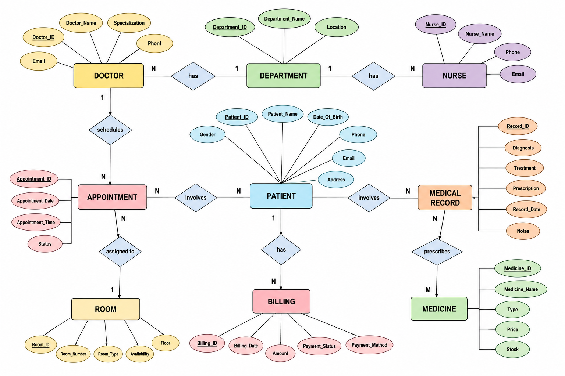
Figure 6.1: ER Diagram of the Hospital Management System

Reading the diagram: a Department has many Doctors and many Nurses; a Doctor schedules many Appointments; each Appointment involves a Patient and is assigned to a Room; a Patient has many Medical Records and many Bills; and a Medical Record prescribes Medicines.

6.4 Relationships & Cardinality

Entity 1 | Relationship | Entity 2 | Cardinality | Implemented By
Department | has | Doctor | 1 : N | Doctor.Department_ID (FK)
Department | has | Nurse | 1 : N | Nurse.Department_ID (FK)
Doctor | schedules | Appointment | 1 : N | Appointment.Doctor_ID (FK)
Patient | involves | Appointment | 1 : N | Appointment.Patient_ID (FK)
Room | assigned to | Appointment | 1 : N | Appointment.Room_ID (FK)
Patient | involves | Medical_Record | 1 : N | Medical_Record.Patient_ID (FK)
Doctor | writes | Medical_Record | 1 : N | Medical_Record.Doctor_ID (FK)
Patient | has | Billing | 1 : N | Billing.Patient_ID (FK)
Appointment | generates | Billing | 1 : N | Billing.Appointment_ID (FK)
Medical_Record | prescribes | Medicine | M : N | Prescription attribute of Medical_Record
Table 6.3: Relationships and Cardinality
Notes. In the ER diagram the “involves” relationships of Patient are drawn with N at both ends to show that a patient takes part in many appointments and records. In the relational schema each appointment and each record belongs to exactly one patient, so the mapping is 1 : N with the foreign key on the N side. The many-to-many “prescribes” relationship is stored in the current design as the Prescription text attribute of Medical_Record; a separate junction table is listed under future improvements.

6.5 Relational Database Schema
Mapping rule: each entity became one relation, and each 1 : N relationship placed a foreign key on the N side.
Relation | Relational Schema | Keys
Patient | Patient (Patient_ID, Patient_Name, Date_Of_Birth, Gender, Phone, Email, Address) | PK: Patient_ID
Doctor | Doctor (Doctor_ID, Doctor_Name, Specialization, Phone, Email, Department_ID) | PK: Doctor_ID  FK: Department_ID
Department | Department (Department_ID, Department_Name, Location) | PK: Department_ID
Nurse | Nurse (Nurse_ID, Nurse_Name, Phone, Email, Department_ID) | PK: Nurse_ID  FK: Department_ID
Room | Room (Room_ID, Room_Number, Room_Type, Floor, Availability) | PK: Room_ID
Appointment | Appointment (Appointment_ID, Patient_ID, Doctor_ID, Room_ID, Appointment_Date, Appointment_Time, Status) | PK: Appointment_ID  FK: Patient_ID, Doctor_ID, Room_ID
Medical_Record | Medical_Record (Record_ID, Patient_ID, Doctor_ID, Diagnosis, Treatment, Prescription, Record_Date, Notes) | PK: Record_ID  FK: Patient_ID, Doctor_ID
Medicine | Medicine (Medicine_ID, Medicine_Name, Type, Price, Stock, Expiry_Date) | PK: Medicine_ID
Billing | Billing (Bill_ID, Patient_ID, Appointment_ID, Billing_Date, Amount, Payment_Status, Payment_Method) | PK: Bill_ID  FK: Patient_ID, Appointment_ID
Table 6.4: Relational Schema of the Nine Relations
The detailed schema with data types and constraints for every column is given below.
Table | Column | Data Type | PK/FK | Constraints
Patient | Patient_ID | INT | PK | PRIMARY KEY
Patient | Patient_Name | VARCHAR(50) | — | NOT NULL
Patient | Date_Of_Birth | DATE | — | NULL allowed
Patient | Gender | CHAR(1) | — | CHECK (M, F, O)
Patient | Phone | VARCHAR(15) | — | NOT NULL, UNIQUE
Patient | Email | VARCHAR(50) | — | UNIQUE
Patient | Address | VARCHAR(100) | — | DEFAULT 'Not given'
Doctor | Doctor_ID | INT | PK | PRIMARY KEY
Doctor | Doctor_Name | VARCHAR(50) | — | NOT NULL
Doctor | Specialization | VARCHAR(50) | — | NOT NULL
Doctor | Phone | VARCHAR(15) | — | UNIQUE
Doctor | Email | VARCHAR(50) | — | UNIQUE
Doctor | Department_ID | INT | FK | NOT NULL, FK → Department
Department | Department_ID | INT | PK | PRIMARY KEY
Department | Department_Name | VARCHAR(50) | — | NOT NULL, UNIQUE
Department | Location | VARCHAR(50) | — | NULL allowed
Nurse | Nurse_ID | INT | PK | PRIMARY KEY
Nurse | Nurse_Name | VARCHAR(50) | — | NOT NULL
Nurse | Phone | VARCHAR(15) | — | UNIQUE
Nurse | Email | VARCHAR(50) | — | UNIQUE
Nurse | Department_ID | INT | FK | NOT NULL, FK → Department
Room | Room_ID | INT | PK | PRIMARY KEY
Room | Room_Number | VARCHAR(10) | — | NOT NULL, UNIQUE
Room | Room_Type | VARCHAR(20) | — | CHECK (General, Semi-private, Private, ICU)
Room | Floor | INT | — | NULL allowed
Room | Availability | CHAR(3) | — | DEFAULT 'Yes', CHECK (Yes, No)
Appointment | Appointment_ID | INT | PK | PRIMARY KEY
Appointment | Patient_ID | INT | FK | NOT NULL, FK → Patient
Appointment | Doctor_ID | INT | FK | NOT NULL, FK → Doctor
Appointment | Room_ID | INT | FK | NULL allowed, FK → Room
Appointment | Appointment_Date | DATE | — | NOT NULL
Appointment | Appointment_Time | TIME | — | NULL allowed
Appointment | Status | VARCHAR(12) | — | DEFAULT 'Booked', CHECK (Booked, Completed, Cancelled)
Medical_Record | Record_ID | INT | PK | PRIMARY KEY
Medical_Record | Patient_ID | INT | FK | NOT NULL, FK → Patient
Medical_Record | Doctor_ID | INT | FK | NOT NULL, FK → Doctor
Medical_Record | Diagnosis | VARCHAR(100) | — | NOT NULL
Medical_Record | Treatment | VARCHAR(200) | — | NULL allowed
Medical_Record | Prescription | VARCHAR(200) | — | NULL allowed
Medical_Record | Record_Date | DATE | — | DEFAULT (CURRENT_DATE)
Medical_Record | Notes | VARCHAR(255) | — | NULL allowed
Medicine | Medicine_ID | INT | PK | PRIMARY KEY
Medicine | Medicine_Name | VARCHAR(50) | — | NOT NULL
Medicine | Type | VARCHAR(20) | — | NULL allowed
Medicine | Price | DECIMAL(8,2) | — | NOT NULL, CHECK >= 0
Medicine | Stock | INT | — | NOT NULL, DEFAULT 0, CHECK >= 0
Medicine | Expiry_Date | DATE | — | NOT NULL
Billing | Bill_ID | INT | PK | PRIMARY KEY
Billing | Patient_ID | INT | FK | NOT NULL, FK → Patient
Billing | Appointment_ID | INT | FK | NOT NULL, FK → Appointment
Billing | Billing_Date | DATE | — | DEFAULT (CURRENT_DATE)
Billing | Amount | DECIMAL(10,2) | — | NOT NULL, CHECK > 0
Billing | Payment_Status | VARCHAR(10) | — | DEFAULT 'Pending', CHECK (Paid, Pending)
Billing | Payment_Method | VARCHAR(15) | — | NULL allowed
Table 6.5: Detailed Schema with Data Types and Constraints

6.6 Primary & Foreign Keys
Every table has a single-column primary key that is never NULL or repeated (entity integrity). Foreign keys accept only values that exist in the parent table (referential integrity), so a bill or appointment can never point to a missing patient.
Child Table | Foreign Key | References
Doctor | Department_ID | Department (Department_ID)
Nurse | Department_ID | Department (Department_ID)
Appointment | Patient_ID | Patient (Patient_ID)
Appointment | Doctor_ID | Doctor (Doctor_ID)
Appointment | Room_ID | Room (Room_ID)
Medical_Record | Patient_ID | Patient (Patient_ID)
Medical_Record | Doctor_ID | Doctor (Doctor_ID)
Billing | Patient_ID | Patient (Patient_ID)
Billing | Appointment_ID | Appointment (Appointment_ID)
Table 6.6: Foreign Keys and the Parent Tables They Reference
The figure below shows how the Appointment table links a Patient and a Doctor through its two foreign keys.
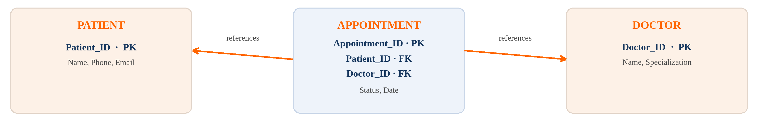
Figure 6.2: Primary and Foreign Key Links of the Appointment Table

6.7 Normalization
Normalisation removes redundancy and prevents insertion, update and deletion anomalies. The design moves from an unnormalised form (UNF) to Third Normal Form (3NF).

Stage | Rule | How it was applied in HMS
UNF | All data kept in one large record. | One record holds patient, doctor, department, diagnosis, medicines and bill together, repeated for every visit.
1NF | Every attribute is atomic; no repeating groups. | Values such as name, phone, address, diagnosis and treatment are stored in separate single-valued columns; repeated visits become separate rows.
2NF | No partial dependency on a key. | Each entity has its own single-column primary key, so every non-key column depends on the whole key; patient facts are not repeated in appointments or bills.
3NF | No transitive dependency. | Doctor_ID → Department_ID → Department_Name is a transitive chain, so Department is a separate table and Doctor keeps only Department_ID as a foreign key.
Table 6.7: Normalisation Steps Applied

7. DATABASE IMPLEMENTATION

7.1 DDL – Database and Table Creation
The database HospitalDB is created first, then the tables are created in foreign-key dependency order (Department → Doctor / Nurse → Patient → Room → Appointment → Medical_Record → Medicine → Billing) so that every parent table exists before its child tables.
-- HospitalDB : Hospital Management System (MySQL)
DROP DATABASE IF EXISTS HospitalDB;
CREATE DATABASE HospitalDB;
USE HospitalDB;

-- 1. DEPARTMENT
CREATE TABLE Department (
Department_ID INT PRIMARY KEY,
Department_Name VARCHAR(50) NOT NULL UNIQUE,
Location VARCHAR(50)
);

-- 2. DOCTOR
CREATE TABLE Doctor (
Doctor_ID INT PRIMARY KEY,
Doctor_Name VARCHAR(50) NOT NULL,
Specialization VARCHAR(50) NOT NULL,
Phone VARCHAR(15) UNIQUE,
Email VARCHAR(50) UNIQUE,
Department_ID INT NOT NULL,
FOREIGN KEY (Department_ID) REFERENCES Department(Department_ID)
);

-- 3. NURSE
CREATE TABLE Nurse (
Nurse_ID INT PRIMARY KEY,
Nurse_Name VARCHAR(50) NOT NULL,
Phone VARCHAR(15) UNIQUE,
Email VARCHAR(50) UNIQUE,
Department_ID INT NOT NULL,
FOREIGN KEY (Department_ID) REFERENCES Department(Department_ID)
);

-- 4. PATIENT
CREATE TABLE Patient (
Patient_ID INT PRIMARY KEY,
Patient_Name VARCHAR(50) NOT NULL,
Date_Of_Birth DATE,
Gender CHAR(1) CHECK (Gender IN ('M','F','O')),
Phone VARCHAR(15) UNIQUE NOT NULL,
Email VARCHAR(50) UNIQUE,
Address VARCHAR(100) DEFAULT 'Not given'
);

-- 5. ROOM
CREATE TABLE Room (
Room_ID INT PRIMARY KEY,
Room_Number VARCHAR(10) UNIQUE NOT NULL,
Room_Type VARCHAR(20)
CHECK (Room_Type IN ('General','Semi-private','Private','ICU')),
Floor INT,
Availability CHAR(3) DEFAULT 'Yes' CHECK (Availability IN ('Yes','No'))
);

-- 6. APPOINTMENT
CREATE TABLE Appointment (
Appointment_ID INT PRIMARY KEY,
Patient_ID INT NOT NULL,
Doctor_ID INT NOT NULL,
Room_ID INT,
Appointment_Date DATE NOT NULL,
Appointment_Time TIME,
Status VARCHAR(12) DEFAULT 'Booked'
CHECK (Status IN ('Booked','Completed','Cancelled')),
FOREIGN KEY (Patient_ID) REFERENCES Patient(Patient_ID),
FOREIGN KEY (Doctor_ID) REFERENCES Doctor(Doctor_ID),
FOREIGN KEY (Room_ID) REFERENCES Room(Room_ID)
);

-- 7. MEDICAL_RECORD
CREATE TABLE Medical_Record (
Record_ID INT PRIMARY KEY,
Patient_ID INT NOT NULL,
Doctor_ID INT NOT NULL,
Diagnosis VARCHAR(100) NOT NULL,
Treatment VARCHAR(200),
Prescription VARCHAR(200),
Record_Date DATE DEFAULT (CURRENT_DATE),
Notes VARCHAR(255),
FOREIGN KEY (Patient_ID) REFERENCES Patient(Patient_ID),
FOREIGN KEY (Doctor_ID) REFERENCES Doctor(Doctor_ID)
);

-- 8. MEDICINE
CREATE TABLE Medicine (
Medicine_ID INT PRIMARY KEY,
Medicine_Name VARCHAR(50) NOT NULL,
Type VARCHAR(20),
Price DECIMAL(8,2) NOT NULL CHECK (Price >= 0),
Stock INT NOT NULL DEFAULT 0 CHECK (Stock >= 0),
Expiry_Date DATE NOT NULL
);

-- 9. BILLING
CREATE TABLE Billing (
Bill_ID INT PRIMARY KEY,
Patient_ID INT NOT NULL,
Appointment_ID INT NOT NULL,
Billing_Date DATE DEFAULT (CURRENT_DATE),
Amount DECIMAL(10,2) NOT NULL CHECK (Amount > 0),
Payment_Status VARCHAR(10) DEFAULT 'Pending'
CHECK (Payment_Status IN ('Paid','Pending')),
Payment_Method VARCHAR(15),
FOREIGN KEY (Patient_ID) REFERENCES Patient(Patient_ID),
FOREIGN KEY (Appointment_ID) REFERENCES Appointment(Appointment_ID)
);

7.2 Sample Data – DML
Each table was filled with representative records. Data is inserted in the same dependency order used for table creation.
Table | No. of Records | Source
Department | 05 | insert_data.sql — Department seed records
Doctor | 12 | insert_data.sql — Doctor seed records
Nurse | 10 | insert_data.sql — Nurse seed records
Patient | 20 | insert_data.sql — Patient seed records
Room | 15 | insert_data.sql — Room seed records
Appointment | 25 | insert_data.sql — Appointment seed records
Medical_Record | 18 | insert_data.sql — Medical record seed records
Medicine | 20 | insert_data.sql — Medicine seed records
Billing | 20 | insert_data.sql — Billing seed records
Total | 145
Table 7.1: Number of Sample Records per Table
A representative extract of the insert script is shown below.
INSERT INTO Department VALUES
(1,'Cardiology','Block A - 2nd Floor'),
(2,'Orthopaedics','Block B - 1st Floor');

INSERT INTO Doctor (Doctor_ID, Doctor_Name, Specialization, Department_ID) VALUES
(11,'Dr. Arun Kumar','Cardiologist',1),
(12,'Dr. Priya Rao','Orthopaedic Surgeon',2);

INSERT INTO Patient VALUES
(101,'Ravi Kumar','2001-05-14','M','9876543210','ravi@mail.com','Kakinada');
INSERT INTO Patient (Patient_ID, Patient_Name, Gender, Phone) VALUES
(102,'Sneha Reddy','F','9123456780');

INSERT INTO Appointment
(Appointment_ID, Patient_ID, Doctor_ID, Appointment_Date, Status) VALUES
(5001,101,11,'2026-09-10','Booked'),
(5002,102,12,'2026-09-11','Completed');

INSERT INTO Medical_Record
(Record_ID, Patient_ID, Doctor_ID, Diagnosis, Treatment) VALUES
(7001,101,11,'Hypertension','Regular monitoring and medication'),
(7002,102,12,'Knee pain','Physiotherapy and medication');

INSERT INTO Medicine VALUES
(301,'Paracetamol','Tablet',25,100,'2027-12-31'),
(302,'Amoxicillin','Capsule',80,50,'2027-06-30'),
(303,'Vitamin D','Tablet',120,40,'2028-01-31');

INSERT INTO Billing
(Bill_ID, Patient_ID, Appointment_ID, Billing_Date, Amount, Payment_Status) VALUES
(9001,101,5001,'2026-09-30',4500,'Paid'),
(9002,102,5002,'2026-09-11',32000,'Paid');

7.3 Constraints & Data Integrity
Constraint | Applied On | Purpose | Example
PRIMARY KEY | All nine tables | Uniquely identifies each row; no NULL or repeated key. | Patient_ID INT PRIMARY KEY
FOREIGN KEY | Doctor, Nurse, Appointment, Medical_Record, Billing | Links child rows to a valid parent row. | Appointment.Patient_ID → Patient
NOT NULL | Names, phone, dates, amounts, foreign keys | Required fields cannot be left empty. | Patient_Name NOT NULL
UNIQUE | Patient Phone / Email, Doctor and Nurse Phone / Email, Room_Number, Department_Name | No two records share the same contact or number. | Phone UNIQUE
CHECK | Gender, Status, Payment_Status, Room_Type, Availability, Price, Stock, Amount | Accepts only valid values and ranges. | Gender IN ('M','F','O')
DEFAULT | Address, Appointment Status, Payment_Status, Room Availability, Stock, dates | Supplies a value when none is given. | Status DEFAULT 'Booked'
Table 7.2: Constraints Applied in HospitalDB

7.4 DDL, DML & DQL Operations
SQL statements are grouped by purpose. DDL defines and modifies the structure, DML adds, changes and removes the data, and DQL retrieves it.

DDL – Data Definition Language
CREATE TABLE Room (Room_ID INT PRIMARY KEY, Room_Number VARCHAR(10) UNIQUE,
Room_Type VARCHAR(20), Availability CHAR(3) DEFAULT 'Yes');
ALTER TABLE Doctor ADD Experience_Years INT;
TRUNCATE TABLE Medicine; -- removes all rows, keeps the structure
DROP TABLE Medicine; -- removes the table completely

DML – Data Manipulation Language
INSERT INTO Patient (Patient_ID, Patient_Name, Gender, Phone)
VALUES (121, 'Anitha Rao', 'F', '9000012345');
UPDATE Appointment SET Status = 'Completed' WHERE Appointment_ID = 5001;
DELETE FROM Appointment WHERE Status = 'Cancelled';

DQL – Data Query Language
SELECT * FROM Doctor WHERE Specialization = 'Cardiologist';
SELECT * FROM Appointment ORDER BY Appointment_Date ASC;
SELECT Department_ID, COUNT(*) AS Total_Doctors FROM Doctor
GROUP BY Department_ID HAVING COUNT(*) > 2;
SELECT DISTINCT Specialization FROM Doctor;

Clause order: SELECT → FROM → WHERE → GROUP BY → HAVING → ORDER BY → LIMIT.

7.5 CRUD Operations & SQL Queries
The four basic CRUD operations were performed on the Patient table:
-- C : CREATE
INSERT INTO Patient (Patient_ID, Patient_Name, Gender, Phone)
VALUES (130, 'Kiran', 'M', '9812345670');
-- R : READ
SELECT p.Patient_Name, a.Status
FROM Patient p JOIN Appointment a ON p.Patient_ID = a.Patient_ID;
-- U : UPDATE
UPDATE Patient SET Phone = '9898989898' WHERE Patient_ID = 130;
-- D : DELETE
DELETE FROM Patient WHERE Patient_ID = 130;

The complete set of queries used for reports and analysis is listed below and saved in queries.sql.
S.No | Operation / Query | Purpose | Reference
1 | Filtered SELECT | List all doctors with a given specialization. | queries.sql Q1
2 | SELECT + ORDER BY | Show appointments in date order. | queries.sql Q2
3 | SELECT DISTINCT | List each specialization once. | queries.sql Q3
4 | GROUP BY + HAVING | Departments having more than two doctors. | queries.sql Q4
5 | LIKE filtering | Search patients by the start of their name. | queries.sql Q5
6 | JOIN (2 tables) | Patient name with appointment status. | queries.sql Q6
7 | JOIN (3 tables) | Patient + Doctor + Department report. | queries.sql Q7
8 | JOIN (3 tables) | Medical records with patient and doctor names. | queries.sql Q8
9 | Aggregate functions | Total bills, revenue, average and highest bill. | queries.sql Q9
10 | GROUP BY + aggregates | Bill count and amount by payment status. | queries.sql Q10
11 | JOIN + WHERE | Patients whose payment is pending. | queries.sql Q11
12 | Subquery | Bills higher than the average bill. | queries.sql Q12
13 | Date function | Medicines expiring within six months. | queries.sql Q13
14 | Filtered SELECT | Medicines with low stock. | queries.sql Q14
15 | LEFT JOIN + GROUP BY | Number of doctors in every department. | queries.sql Q15
16 | VIEW | Reusable patient–doctor–department appointment view. | queries.sql Q16
17 | INDEX | Speed up searches on patient name and appointment date. | queries.sql Q17
Table 7.3: SQL Operations and Queries

-- Q5 Search patients by name
SELECT Patient_ID, Patient_Name, Phone FROM Patient WHERE Patient_Name LIKE 'R%';

-- Q7 JOIN across three tables (Patient + Doctor + Department)
SELECT p.Patient_Name, d.Doctor_Name, dp.Department_Name
FROM Appointment a
JOIN Patient p ON a.Patient_ID = p.Patient_ID
JOIN Doctor d ON a.Doctor_ID = d.Doctor_ID
JOIN Department dp ON d.Department_ID = dp.Department_ID;

-- Q8 Medical records with patient and doctor
SELECT r.Record_ID, p.Patient_Name, d.Doctor_Name, r.Diagnosis, r.Treatment
FROM Medical_Record r
JOIN Patient p ON r.Patient_ID = p.Patient_ID
JOIN Doctor d ON r.Doctor_ID = d.Doctor_ID;

-- Q9 Aggregate functions on Billing
SELECT COUNT(*) AS Total_Bills, SUM(Amount) AS Revenue,
AVG(Amount) AS Average_Bill, MAX(Amount) AS Highest_Bill
FROM Billing;

-- Q10 Bills grouped by payment status
SELECT Payment_Status, COUNT(*) AS Bills, SUM(Amount) AS Total
FROM Billing GROUP BY Payment_Status;

-- Q11 Pending payments
SELECT p.Patient_Name, b.Bill_ID, b.Amount
FROM Billing b JOIN Patient p ON b.Patient_ID = p.Patient_ID
WHERE b.Payment_Status = 'Pending';

-- Q12 Subquery: bills above the average
SELECT Bill_ID, Patient_ID, Amount FROM Billing
WHERE Amount > (SELECT AVG(Amount) FROM Billing);

-- Q13 Medicines expiring within six months
SELECT Medicine_Name, Expiry_Date FROM Medicine
WHERE Expiry_Date BETWEEN CURDATE() AND DATE_ADD(CURDATE(), INTERVAL 6 MONTH);

-- Q14 Low-stock medicines
SELECT Medicine_Name, Stock FROM Medicine WHERE Stock < 50;

-- Q15 Doctors per department
SELECT dp.Department_Name, COUNT(d.Doctor_ID) AS Total_Doctors
FROM Department dp LEFT JOIN Doctor d ON d.Department_ID = dp.Department_ID
GROUP BY dp.Department_Name;

-- Q16 VIEW
CREATE VIEW Patient_Doctor_Department AS
SELECT a.Appointment_ID, p.Patient_Name, d.Doctor_Name, dp.Department_Name,
a.Appointment_Date, a.Status
FROM Appointment a
JOIN Patient p ON a.Patient_ID = p.Patient_ID
JOIN Doctor d ON a.Doctor_ID = d.Doctor_ID
JOIN Department dp ON d.Department_ID = dp.Department_ID;

-- Q17 INDEXES
CREATE INDEX idx_patient_name ON Patient (Patient_Name);
CREATE INDEX idx_appointment_date ON Appointment (Appointment_Date);

Output of Q7 (Patient + Doctor + Department JOIN):
Patient | Doctor | Department
Ravi Kumar | Dr. Arun Kumar | Cardiology
Sneha Reddy | Dr. Priya Rao | Orthopaedics
Table 7.4: Output of the Three-Table JOIN (Q7)
Output of Q9 (Billing aggregates):
Total_Bills | Revenue | Average_Bill | Highest_Bill
20 | ₹1,84,500 | ₹9,225 | ₹32,000
Table 7.5: Output of the Aggregate Query (Q9)

7.6 Data Integrity & Validation
Four types of integrity are enforced in the database.
Integrity Type | Meaning | How HMS enforces it
Entity integrity | Every table has a primary key; no key value is NULL or repeated. | PRIMARY KEY on all nine tables.
Referential integrity | Foreign keys accept only existing parent values. | FOREIGN KEY constraints: no appointment or bill can point to a missing patient.
Domain integrity | Columns accept only valid types and values. | DATE, INT, VARCHAR and DECIMAL types; CHECK on Gender, Status and Amount.
User-defined integrity | Business rules of the hospital. | Phone and Email are UNIQUE; an appointment date cannot be earlier than today.
Table 7.6: Types of Data Integrity
After data entry, the following validation queries were run. Each query is written to return rows only when a problem exists.
-- 1. Duplicate patient IDs
SELECT Patient_ID, COUNT(*) FROM Patient GROUP BY Patient_ID HAVING COUNT(*) > 1;
-- 2. Orphan appointments (patient missing)
SELECT * FROM Appointment WHERE Patient_ID NOT IN (SELECT Patient_ID FROM Patient);
-- 3. Required patient fields missing
SELECT * FROM Patient WHERE Patient_Name IS NULL OR Phone IS NULL;
-- 4. Expired medicine stock
SELECT * FROM Medicine WHERE Expiry_Date < CURDATE();

No. | Validation Check | Rows Returned | Result
1 | No duplicate patient IDs | 0 | Passed
2 | No orphan appointments | 0 | Passed
3 | Required patient fields validated | 0 | Passed
4 | Medicine expiry checked | 0 | Passed
Table 7.7: Validation Results
Because a “passed” check returns no rows, the results appear as green confirmation bars on the Reports screen of the demo application (Figure 7.4).

7.7 Sample Outputs / Screenshots
The screenshots below are taken from the demo application, which displays the data stored in HospitalDB. The application header shows the project title, “DBMS College Project — Demo Application”, and the team members’ names; the left sidebar provides navigation to all eight modules.

Medical Records
Lists each record with its Record ID, Patient, Doctor, Diagnosis and Treatment. The data comes from a JOIN of Medical_Record, Patient and Doctor (Q8).
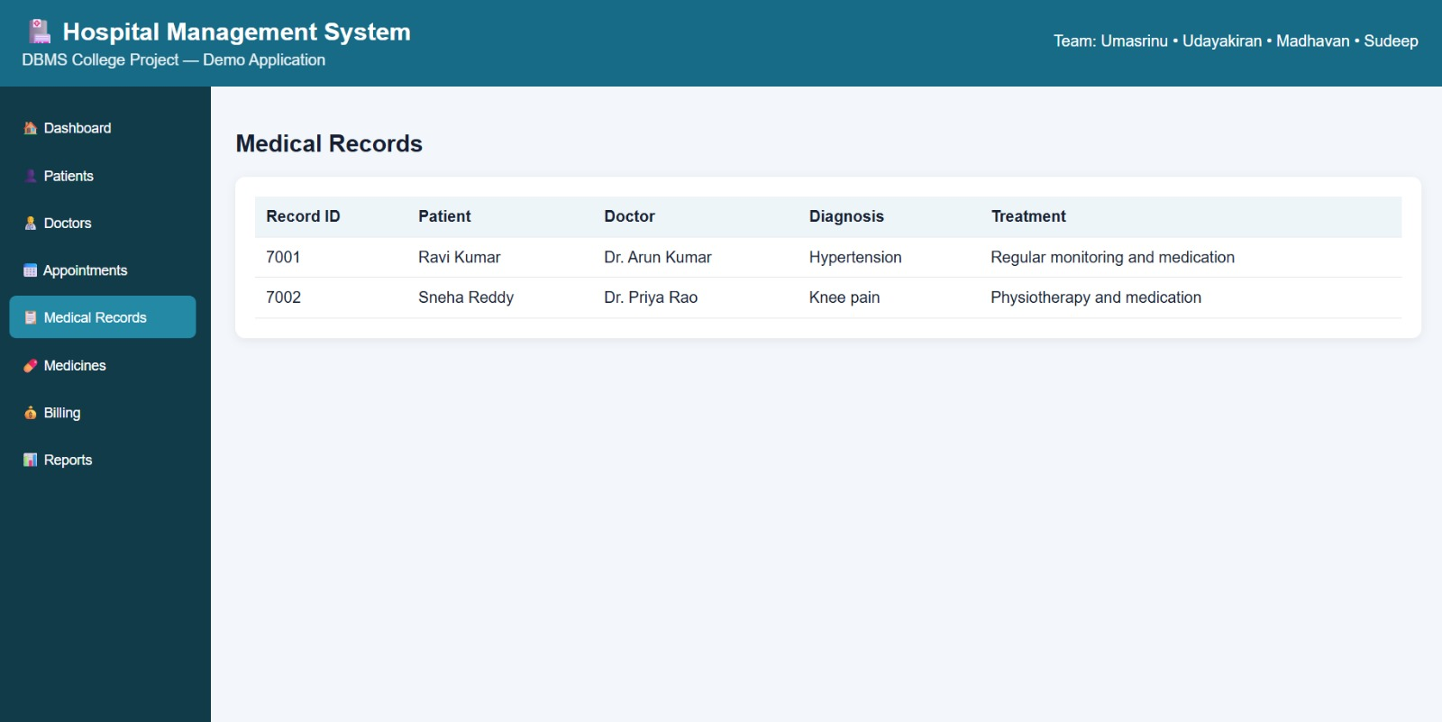
Figure 7.1: Medical Records screen (Medical_Record + Patient + Doctor)

Medicine & Pharmacy
Shows the pharmacy stock with ID, medicine name, type, price, stock quantity and expiry date, e.g. Paracetamol (tablet, ₹25, 100 in stock, expiry 31-12-2027).
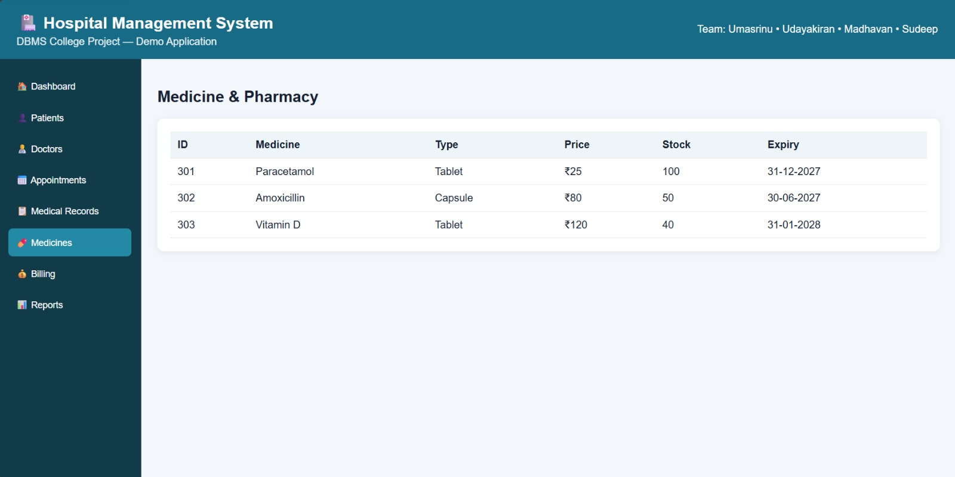
Figure 7.2: Medicine & Pharmacy screen (Medicine table)

Billing Management
The summary cards display the aggregate query results — 20 total bills, revenue of ₹1,84,500, an average bill of ₹9,225 and a highest bill of ₹32,000. The table below lists each bill with its patient, amount, date and payment status (Paid / Pending).
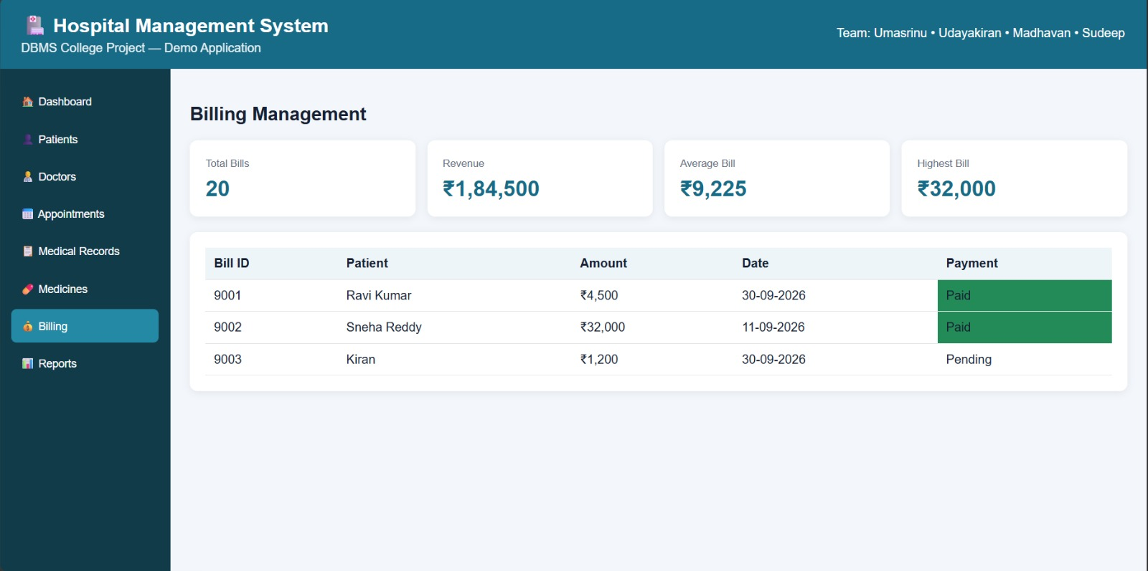
Figure 7.3: Billing Management screen (Billing + Patient, aggregate functions)

Reports & DBMS Features
Demonstrates the three-table JOIN (Patient + Doctor + Department), lists the database concepts used — primary keys, foreign keys, 1NF / 2NF / 3NF, CRUD, DDL, DML, DQL, JOIN, aggregate functions, VIEW, indexes and validation — and shows the four integrity checks as passed.
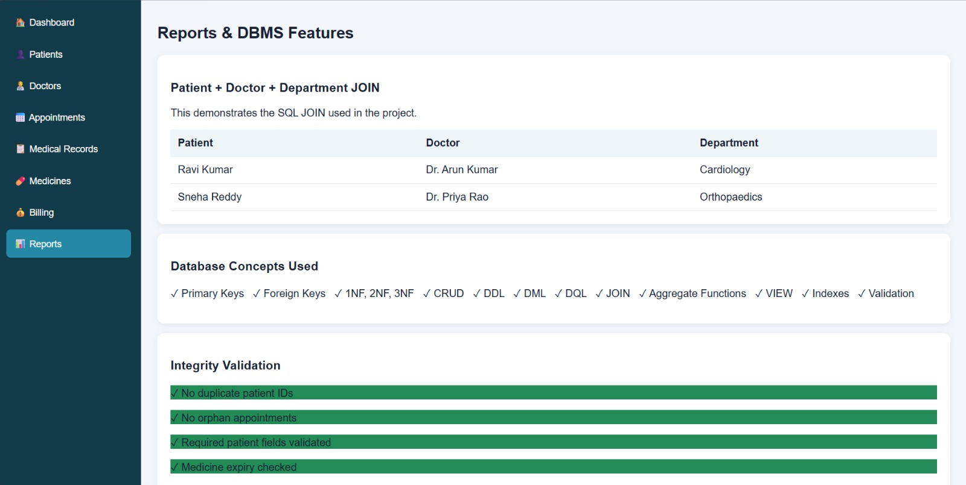
Figure 7.4: Reports & DBMS Features screen (JOIN output and integrity validation)

8. MODULES & FUNCTIONALITIES
The demo application is organised into eight modules, reached from the left navigation menu. Every module reads from or writes to the corresponding tables of HospitalDB.
S.No | Module Name | Functionality | Main Tables
1 | Dashboard | Landing screen of the application with quick access to every module. | All tables
2 | Patients | Registers patients and maintains their identity and contact details; supports search, update and delete. | Patient
3 | Doctors | Maintains doctor records with specialization and department. | Doctor, Department
4 | Appointments | Books appointments between patients and doctors, assigns a room and tracks status (Booked / Completed / Cancelled). | Appointment, Patient, Doctor, Room
5 | Medical Records | Stores the diagnosis and treatment for each patient visit with the treating doctor. | Medical_Record, Patient, Doctor
6 | Medicines | Pharmacy stock: type, price, quantity in stock and expiry date. | Medicine
7 | Billing | Raises bills, shows payment status and summary cards for total bills, revenue, average and highest bill. | Billing, Patient, Appointment
8 | Reports | Shows the JOIN report, the DBMS concepts used and the integrity validation results. | Patient, Doctor, Department, Appointment
Table 8.1: Modules and Functionalities

9. GITHUB REPOSITORY & TEAM RESPONSIBILITIES
Repository Link: https://github.com/umasrinu-125/HOSPITAL-MANAGEMENT-SYSTEM

Folder | Contents
/sql/ | create_tables.sql, insert_data.sql, queries.sql
/docs/ | ER diagram and project report
/screenshots/ | Query output and application screenshots
Table 9.1: Repository Structure
Version-control practice: one repository is shared by all four members; each member works on a separate branch, and changes are merged through pull requests.

Student Name | Roll Number | Role / Responsibility | Status
P. Umasrinu | 25B11AI891 | ER diagram, schema design and normalisation | Completed
P. Udayakiran | 25B11AI880 | Table creation, constraints and sample data | Completed
P. Madhavan | 25B11AI873 | DML / DQL queries, joins and aggregate functions | Completed
P. Sudeep | 25B11AI941 | Validation checks, documentation and demo | Completed
Table 9.2: Team Responsibilities
Project guidance: Mrs. G. L. Narasamba (Guide) and Dr. P. V. V. S. D. Nagendrudu (Co-Guide).

10. DEMONSTRATION OF THE DATABASE
The database is presented to the review panel in four steps.

Step | Activity | What is shown
1 | Show the schema | SHOW TABLES; DESC Patient; SHOW CREATE TABLE Appointment;
2 | Insert live data | Register a new patient and book an appointment for the panel.
3 | Run queries | Joins, GROUP BY reports and CRUD operations on screen.
4 | Prove the constraints | Attempt a duplicate phone number or an invalid Status — SQL rejects both.
Table 10.1: Demonstration Steps
Expected behaviour of the constraint test in Step 4:
-- Duplicate phone number
INSERT INTO Patient (Patient_ID, Patient_Name, Gender, Phone)
VALUES (131,'Test','M','9876543210');
-- ERROR 1062 (23000): Duplicate entry '9876543210' for key 'patient.Phone'

-- Invalid appointment status
INSERT INTO Appointment
(Appointment_ID, Patient_ID, Doctor_ID, Appointment_Date, Status)
VALUES (5099,101,11,'2026-10-05','Postponed');
-- ERROR 3819 (HY000): Check constraint 'appointment_chk_1' is violated.

11. ENHANCEMENTS & FUTURE IMPROVEMENTS
The current system meets its objectives as a database project. It can be extended in the following ways:
- A separate Prescription table (Medical_Record ↔ Medicine) to store the many-to-many prescribing relationship with dose and quantity.
- Triggers and stored procedures — for example, reducing medicine stock automatically when a medicine is issued, and blocking appointments dated in the past.
- Automatic bill calculation from consultation, room and medicine charges.
- User authentication and role-based access for admin, doctor, nurse and pharmacist.
- Richer dashboards and reports, such as monthly revenue and department-wise patient load.
- Alerts for low stock, near-expiry medicine and appointment reminders by SMS or e-mail.
- Audit logging and regular database backup.
- A full front-end and back-end application connected to the database for day-to-day hospital use.

12. CONCLUSION
The Hospital Management System database was designed from an ER model, converted into normalised relational tables, and implemented in MySQL with full primary key, foreign key and constraint support. Patient, doctor, appointment, medical record, medicine and billing information is now stored once, linked correctly, and retrieved through SQL queries in seconds instead of the minutes a manual register would take.
The SQL scripts demonstrate table creation, data insertion, CRUD operations, joins, aggregate functions, GROUP BY / HAVING, subqueries, a view and indexes, and the validation checks confirm that the data is accurate and duplicate-free. The team divided the work across ER and schema design, table creation and sample data, query development, and validation and documentation.
The result is an accurate database that is ready to support a hospital’s day-to-day operations, with room to grow into a full application through triggers, stored procedures and a connected front end in the future.

13. REFERENCES
- Project SQL scripts: create_tables.sql, insert_data.sql and queries.sql.
- Aditya University — DBMS Capstone Project documentation template and Final Review (Review I & II) presentation template.
- R. Elmasri and S. B. Navathe, Fundamentals of Database Systems, Pearson.
- A. Silberschatz, H. F. Korth and S. Sudarshan, Database System Concepts, McGraw-Hill.
- MySQL Reference Manual, Oracle Corporation — https://dev.mysql.com/doc/
- GitHub repository: Hospital Management System (project repository).

APPENDIX

A. Complete SQL Script Files
The final SQL implementation is supplied through three script files in the /sql/ folder of the repository.

File | Contents
create_tables.sql | CREATE DATABASE HospitalDB and the nine CREATE TABLE statements with keys and constraints (Section 7.1).
insert_data.sql | Sample data for all nine tables — 145 records in total (Section 7.2).
queries.sql | DDL / DML / DQL operations, CRUD, joins, aggregates, subquery, view, indexes and validation checks (Sections 7.4 – 7.6).
Table A.1: SQL Script Files

B. Additional Screenshots / Outputs
The table below maps each application screenshot to the database tables and queries behind it.

Application Screen | Figure | Tables Used | Query / Concept
Medical Records | Figure 7.1 | Medical_Record, Patient, Doctor | JOIN (Q8)
Medicines | Figure 7.2 | Medicine | SELECT, expiry check
Billing | Figure 7.3 | Billing, Patient | Aggregates (Q9)
Reports | Figure 7.4 | Patient, Doctor, Department, Appointment | JOIN (Q7), validation
Table B.1: Screenshot to Database Mapping

